LeetCode Program 231
Link :- https://leetcode.com/problems/power-of-two/

Successful Submission
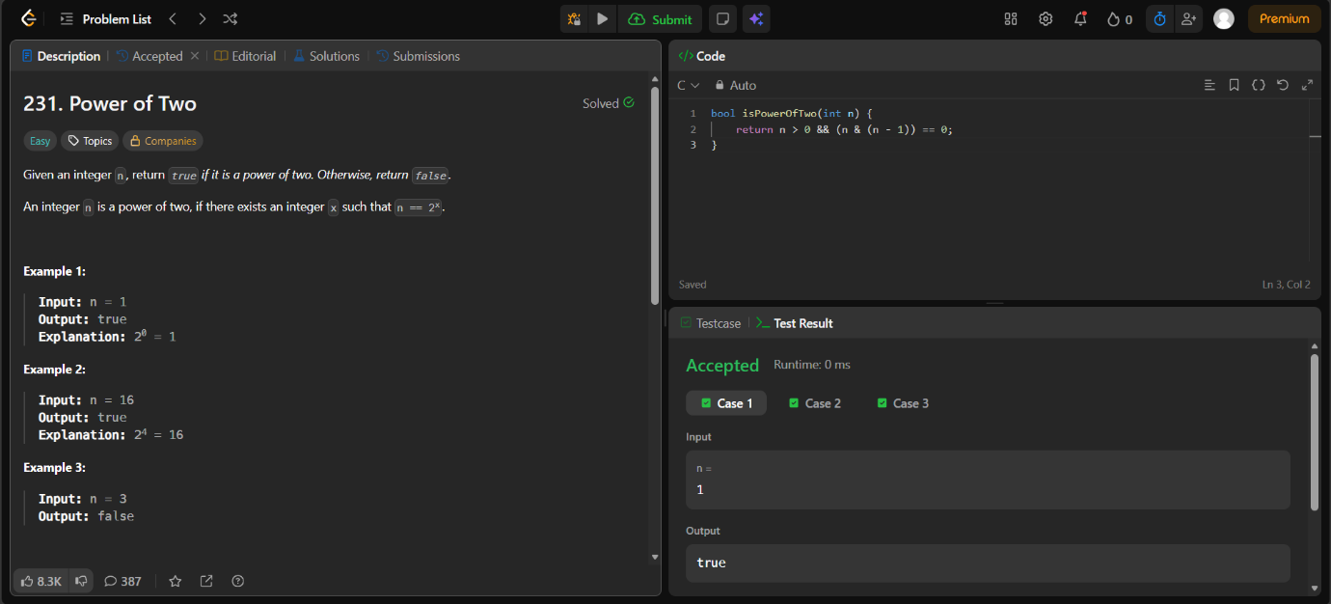
Source Code


